Section 1: Case Summary

Scenario Title: | Exertional Heatstroke
Keywords: | Heat related illness, exertional heat stroke, hyperthermia
Brief Description of Case: | In this case, a 58 y/o male experiences exertional heat stroke on a hot summer day during a heat wave. The team must actively cool the patient while working the patient up for other causes. Ultimately, the patient will require admission to hospital for ongoing treatment.

Goals and Objectives
Educational Goal: | Diagnose and treat exertional heat stroke
Objectives:  (Medical and CRM) | - Maintain a broad differential diagnosis for the hyperthermic and agitated patient  - Recognize and treat exertional heat stroke  - Maintain situational awareness, closed loop communication, and role delegation
EPAs Assessed:

Learners, Setting and Personnel
Target Learners: | ☒ Junior Learners |  | ☒ Senior Learners |  |  | ☒ Staff
 | ☒ Physicians | ☒ Nurses |  | ☒ RTs | ☒ Inter-professional
 | ☐ Other Learners:
Location: | ☒ Sim Lab |  | ☒ In Situ |  |  | ☐ Other:
Recommended Number of Facilitators: | Instructors:
 | Sim Actors:
 | Sim Techs:

Scenario Development
Date of Development: | June 13, 2023
Scenario Developer(s): | Dr. Jared Baylis, Dr. Kelly Huang
Affiliations/Institutions(s): | UBC
Contact E-mail: | jbaylis@qmed.ca, Kelly.huang@alumni.ubc.ca
Last Revision Date: | June 11, 2025
Revised By: | Dr. Connor Avery-Cooper and JoAnne Slinn
Version Number: | 2

Section 2A: Initial Patient Information

- Patient Chart
Patient Name: Chet |  |  |  | Age: 58 | Gender: M | Weight: 85kg
Presenting complaint: Altered LoC
Temp: 41.7 C | HR: 135 | BP: 90/58 |  | RR: 30 | O₂Sat: 96% | FiO₂: Room air
Cap glucose: 5.3 mmol/L |  |  |  | GCS: 13 (E 4 V 4 M 5 )
Triage note:
EMS has brought in a 58 y/o male who was found “acting strangely”. With EMS, the patient has been confused and slurring his speech. He was out running on a hot day. His initial vital signs are:

HR 135, RR 30, T 41.7C (can omit and only give if asked), BP 90/58, O2 sat 96% on room air.

Allergies: NKDA
Past Medical History: HTN |  |  | Current Medications: Ramipril

Section 2B: Extra Patient Information

A. Further History
The patient’s wife was contacted based on ID found in the patient’s wallet. The patient had consumed a couple of beers this while gardening all afternoon. An hour or two later told his wife he was heading out for a jog.

Of note, it is a particularly hot day with temperatures approximately 38 C during a heat wave.
B. Physical Exam
List any pertinent positive and negative findings
Cardio: Normal heart sounds, bounding pulses | Neuro: confused, combative, no focal deficits
Resp: GAEB | Head & Neck: No signs of trauma
Abdo: soft, non tender | MSK/skin: Dry mucous membranes, hot to touch
Other:

Section 3: Technical Requirements/Room Vision

A. Patient
☒ Mannequin (specify type and whether infant/child/adult)
☐ Standardized Patient
☐ Task Trainer
☐ Hybrid
B. Special Equipment Required
Cold water immersion equipment
IV fluids
Crash cart

C. Required Medications
D. Moulage
E. Monitors at Case Onset
☒ Patient on monitor with vitals displayed
☐ Patient not yet on monitor
F. Patient Reactions and Exam
Include any relevant physical exam findings that require mannequin programming or cues from patient
(e.g. – abnormal breath sounds, moaning when RUQ palpated, etc.) May be helpful to frame in ABCDE format.

Section 5: Scenario Progression

Scenario States, Modifiers and Triggers
Patient State/Vitals | Patient Status | Learner Actions, Modifiers & Triggers to Move to Next State |  | Facilitator Notes
1. Baseline State  Rhythm: Sinus  HR: 145  BP: 90/58  RR: 30  O₂SAT: 96 %  T: 41.7 ºC  GCS: 13 | Confused, slurred speech, uncooperative | Expected Learner Actions  IV access  Ensure monitors applied  Ask for core temperature  Cap glucose  Physical exam + history  Remove clothing  Begin cooled fluids IV (4C)  labs, ECG, +/- CT head | Modifiers  - Can opt to not tell learners temperature, and only give when asked  Triggers  For progression to next state  - Once work up ordered 2. Initiate treatment
2. Initiate Treatment | Same as 1st state | Expected Learner Actions  Consider empiric abx for infection post blood cultures  Give fluids bolus for hypotension  Call for cold water immersion  Fan and mist cold water  Ice packs to all skin surfaces  Reduce room temperature  Benzos or dexmedetomidine for agitation/shivering  Insert Foley for urine output and bladder temperature probe  Cooling blanket | Modifiers  - antipyretics are not indicated  Triggers  - Once treatment initiated 3. Investigations return
3. Investigations return  T 40.1  HR 110  BP 104/72  O2 Sat 96%  GCS 14 |  | Expected Learner Actions  Review labs/ECG  Continue fluid resuscitation  Vocalize plan for cooling targets (rapidly to <40, and reaching 36 – 38 in a few hours) Consult hospitalist/internal medicine | Modifiers  Triggers  - End case after handover to hospitalist

Appendix A: Laboratory Results

CBC  WBC 14  Hgb 170  Plt 400  Lytes  Na 147  K 4.5  Cl 102  HCO₃ 18  AG 14  Urea 12  Cr 280  Glucose 5.6  CK 2146  TSH Normal  VBG  pH 7.  pCO₂ 30  HCO₃ 18  Lactate 3.2 | Cardiac/Coags  Trop 14 (hsTn)  INR Normal  aPTT Normal  Biliary  AST 1100  ALT 1200  GGT400  ALP 320  Bili Normal  Lipase Normal  Tox  EtOH 12  ASA Normal  Tylenol Normal  Osmols Normal

Appendix B: ECGs, X-rays, Ultrasounds and Pictures

Paste in any auxiliary files required for running the session. Don’t forget to include their source so you can find them later!

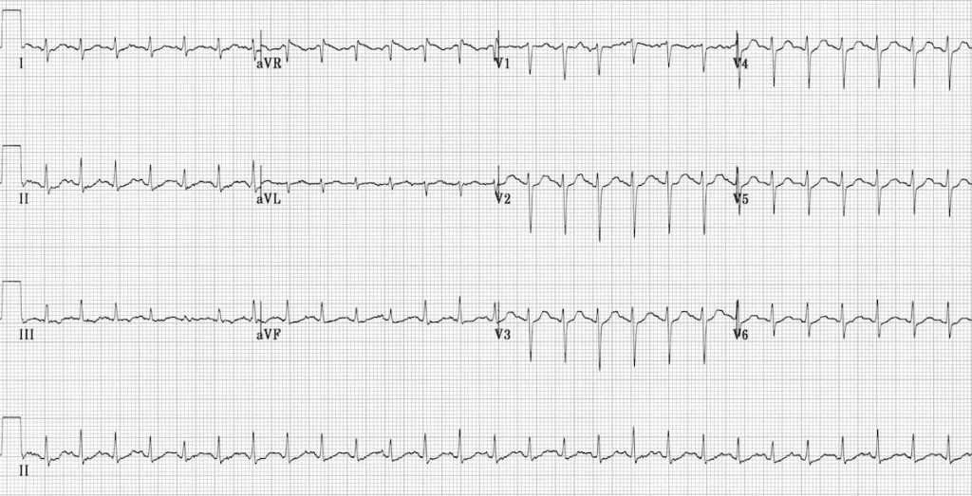
https://litfl.com/sinus-tachycardia-ecg-library/

Appendix C: Facilitator Cheat Sheet & Debriefing Tips

Include key errors to watch for and common challenges with the case. List issues expected to be part of the debriefing discussion. Supplemental information regarding any relevant pathophysiology, guidelines, or management information that may be reviewed during debriefing should be provided for facilitators to have as a reference.

Important discussion points:
- Exertional vs classic heat stroke (exertion related vs heat exposure related)
  - Exertional – with exercise, more likely to be young, no comorbidities, sweaty, flushed skin
  - Classic – comorbidities, older, higher mortality, not as diaphoretic
- Treatment differences (Level 1A for cold water immersion for exertional vs 1C for classic usually due to elderly and comorbid nature of the latter)
- Cold water immersion is 1st line for exertional heat stroke and can cool as rapidly as 0.2C/min
- Target cooling temp of no less than 39C
- Adjuncts – 4C IV fluids, fan and cold water to skin, ice packs to cover entire skin surface. If targeting specific areas, target palms, soles, cheeks.
- Antipyretics are contraindicated in heat related illness – would not work
- If cooling is not working – could intubate and paralyze
- To prevent shivering – benzos, dexmedetomidine

References

1. Lipman et al. (2019) Wilderness Medical Society Clinical Practice Guidelines for the Prevention and Treatment of Heat Illness: 2019 Update. Wilderness Medical Society Clinical Update Guidelines. 30(4), S33 – S46. https://www.wemjournal.org/article/S1080-6032(18)30199-6/fulltext.

2. Platt, M.A., Price, T.M. (2023) Heat Illness. Rosen’s Emergency Medicine: Concepts and Clinical Practice. (10e, Chapter 129) Elselvier Inc.

